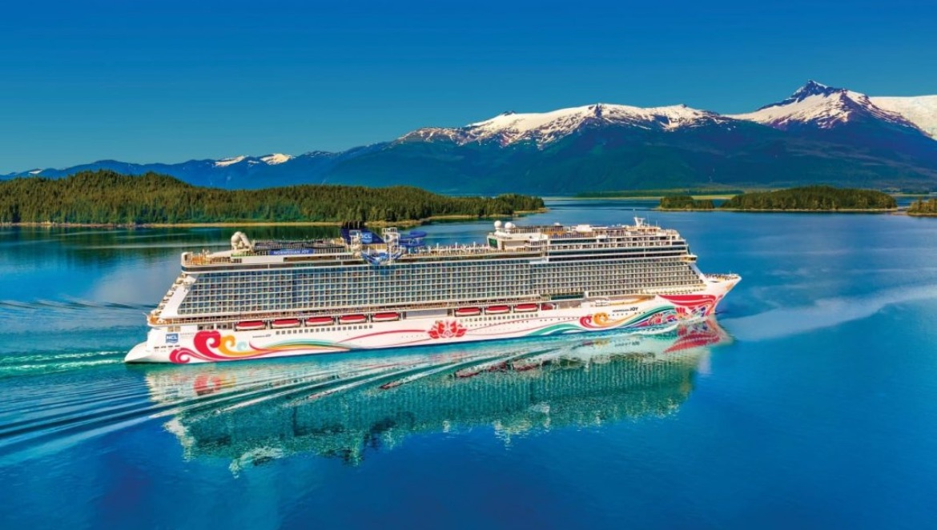


🌟 Experience Alaska 🌟
7-Night Alaska Cruise | August 22 – 30, 2026
Onboard the spectacular Norwegian Encore, Flights roundtrip EWR to Seattle, Hotel stay 1 night pre-cruise
Inside Category IB: $4,400 per person (double occupancy)
Ocean Balcony Category BB: $5,200 per person (double occupancy)
💳 $250 deposit to secure your spot and price due by February 15, 2026.
✅ Final payment due April 1, 2026.

Escape into breathtaking fjords, glaciers, and charming port towns on this unforgettable journey through Alaska. From wildlife encounters to world-class dining and entertainment onboard, every moment is designed to wow you.

What’s Included:
- ✈️ Round-trip flight from Newark to Seattle leaving August 22
- 🛎️ 1-night pre-cruise hotel stay in Seattle
- 🚢 7-night cruise aboard the Norwegian Encore
- 🍽️ All meals onboard, plus morning & afternoon snacks
- 🎭 Broadway-style shows, live music & entertainment
- 🏊 Swimming pools & sporting activities
- 🎲 Las Vegas-style casino
- 🏋️ Health & fitness center
- 🛏️ Cabin steward service & 24-hour amenities
- 🌄 Scenic cruising through Glacier Bay
- ✅ Choice of 2 amenity options (see registration form)
- 💵 Port taxes

Ports of Call & Times:
Sun, Aug 23 Seattle: Depart 4:00 pm
Mon, Aug 24 At Sea
Tue, Aug 25 Juneau: Arrive 2:30 pm | Depart 10:00 pm
Wed, Aug 26 Skagway: Arrive 6:00 am | Depart 8:00 pm
Thu, Aug 27 Cruising Glacier Bay
Fri, Aug 28 Ketchikan (Ward Cove): Arrive 7:00 am | Depart 1:15 pm
Sat, Aug 29 Victoria, BC, Canada: Arrive 8:00 pm | Depart 11:59 pm
Sun, Aug 30 Seattle: Arrive 7:00 am

How to Reserve Your Spot
1. Call BOVE Travel first 📞 718-680-3333 or Michelle Bove at 917-859-9995
• Let us know you’re joining, send us your deposit, complete your registration form
with copy of passport
• Mail Checks/Payable to Bove Travel, 6502 11th Avenue, Brooklyn, NY 11219
2. Credit Card accepted for final payment (NO FEE) and online support
• Call our Tour Company (White Star Tours) and speak to Debbie at 1-800-437-2323
• Be sure to mention BOVE Travel Alaska Cruise, Aug 22–30, 2026

Final Notes
- Valid passport required for entry into Canada.
- Travel insurance is strongly recommended.
- Not Included: Gratuity Fee to be completed during online preboarding check-in and amenity fees.

Trip Cancellation Protection – (see attached)
🛡️ Cancellation protection is encouraged for medical emergencies. The Enhanced option must be paid within 14 days from the day the first deposit is made. An additional Enhanced upgrade – Cancel For Any Reason – is also available. Cancellations must be made no later than 48 hours prior to scheduled departure. Conditions, limitations, and exclusions apply. These plans are only valid for trips booked through Bove/White Star Tours.
Purchase online at https://nta.aontravelprotect.com
or call 1-800-388-1470
Use Tour Operator Location #386097

Tour Company - WHITE STAR TOURS 26 E. Lancaster Avenue, Reading, PA 19607 (800) 437-2323

